|  |
| --- |
|  |
| Test Report for PartIV |
|  |
|  |
| **Group-7** |
| **2013/12/10** |

|  |
| --- |
|  |

**DIRECTORY**

1. Initialize 2

1.1 Welcome 2

1.2 Root Loading 2

1.3 Set Memory 2

1.4 Set PC 3

1.5 Finish Initialization 3

2. Run Program1 5

2.1 Test 1 5

2.2 Test 2 7

3. Run Program2 10

3.1 Test 1 10

3.2 Test 2 12

4. Run Float&Vector Test 15

4.1 Explanation of Float&Vector Test Codes 15

4.2 Start 20

4.3 LDFR 21

4.4 STFR 22

4.5 FADD 23

4.6 FSUB 24

4.7 VADD 25

4.8 VSUB 27

4.9 CNVRT to fixed point 29

4.10 CNVRT to float point 30

1. Initialize
   1. Welcome

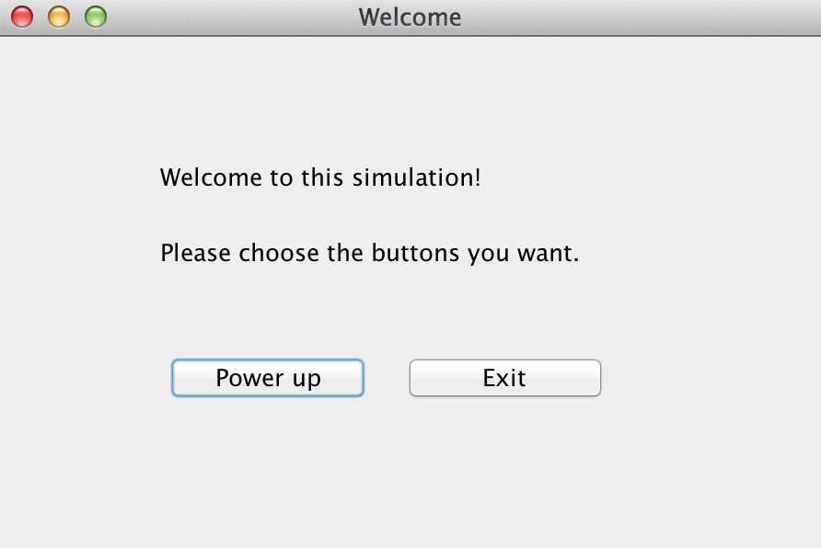

Click the Button “Power up” to start the initialization.

* 1. Root Loading

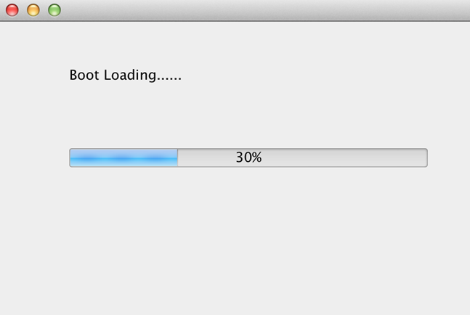

Please just wait until the root loads completely, and then you will see the loading memory window.

* 1. Set Memory

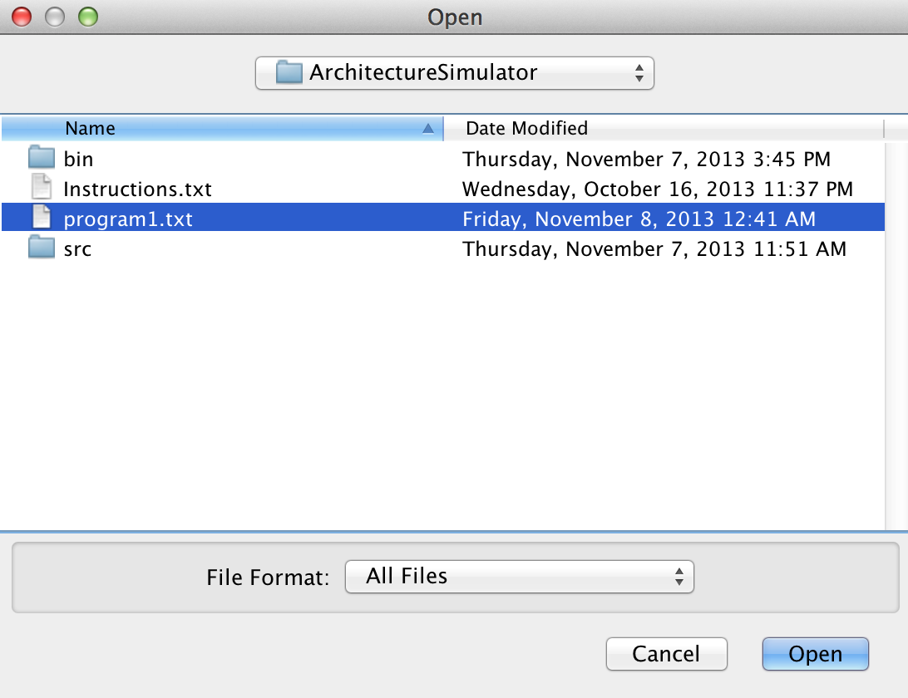

Choose a memory file to load.(Please use program1.txt, program2.txtandFloat&Vector Test.txtwe give).

* 1. Set PC

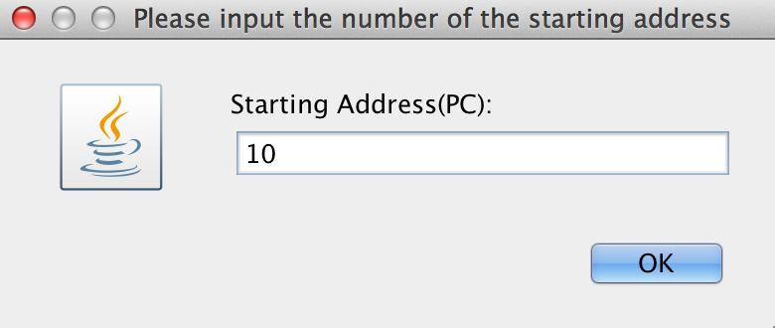

Input the PC number, 10.

* 1. Finish Initialization

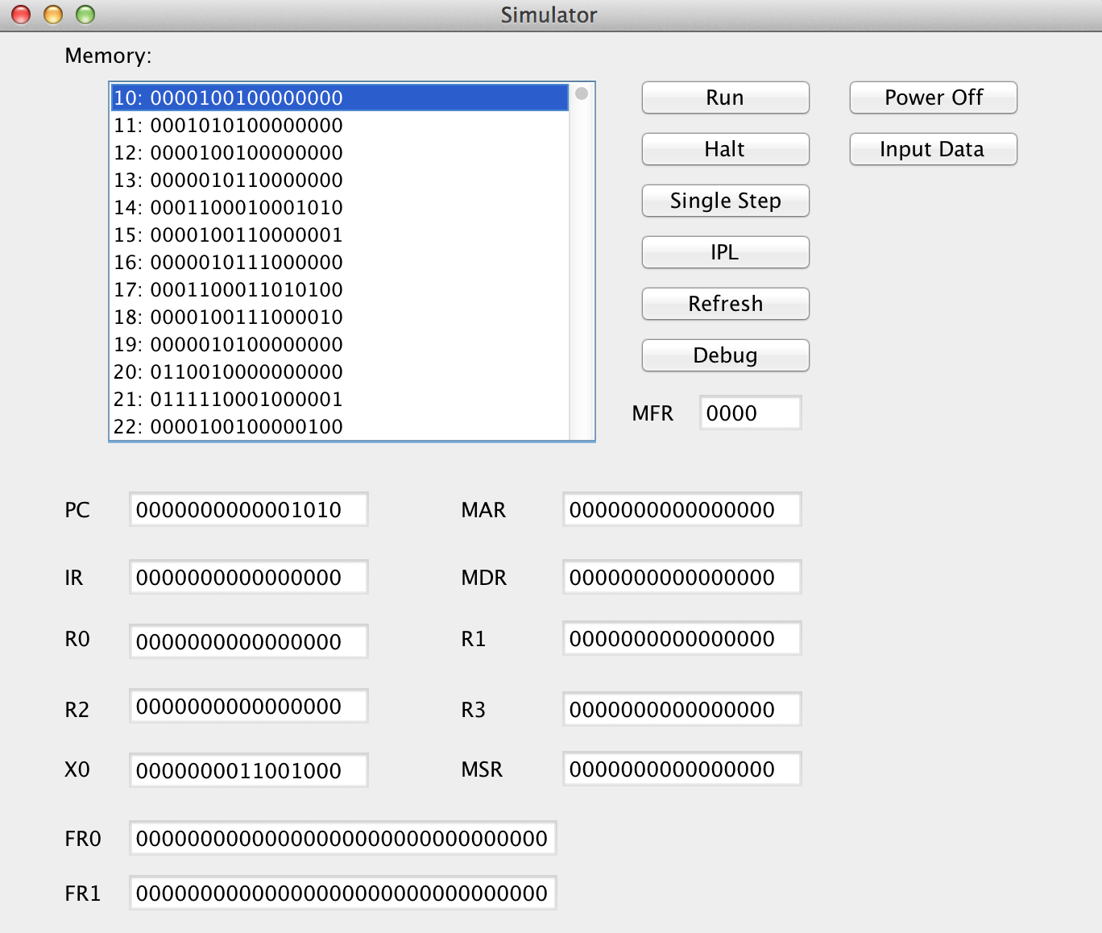

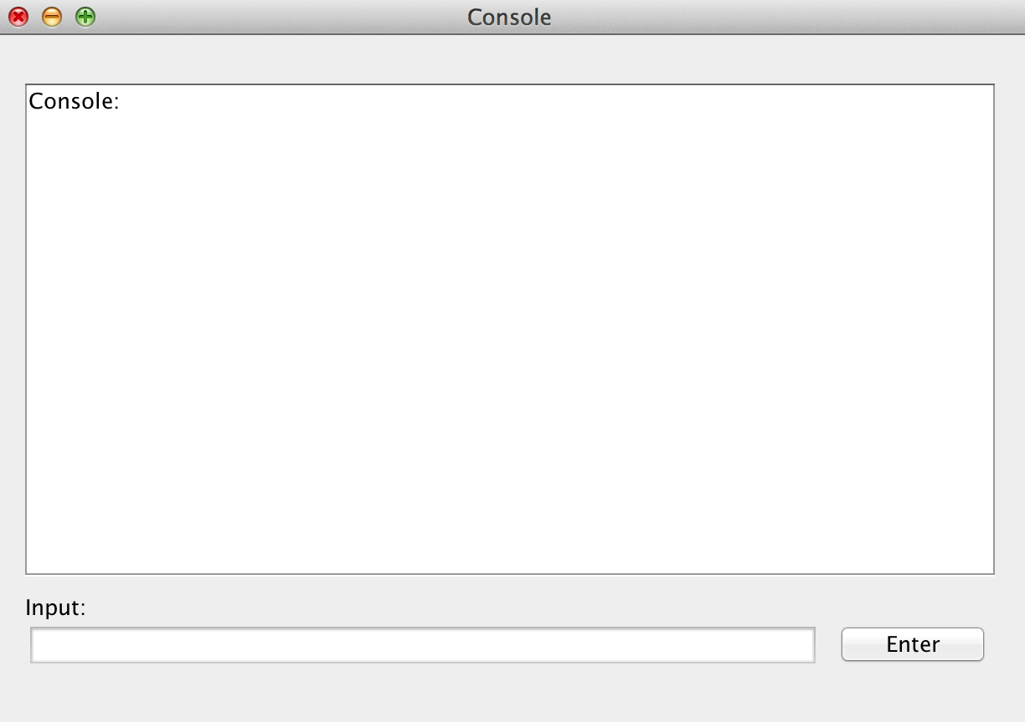

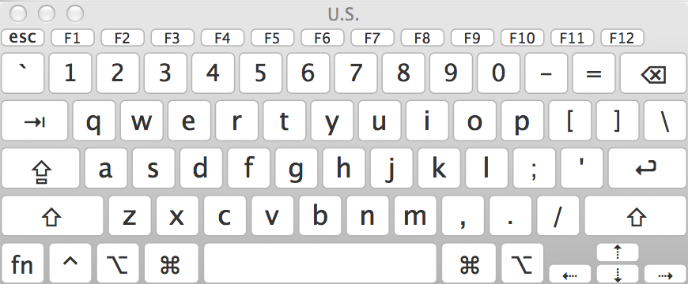

When the initialization finish, you can see these windows like above.

1. RunProgram1
   1. Test 1

When you finish the initialization and all data in this simulator are correct, you can see the window as following (Please use program1.txt when choosing a file to load memory.).

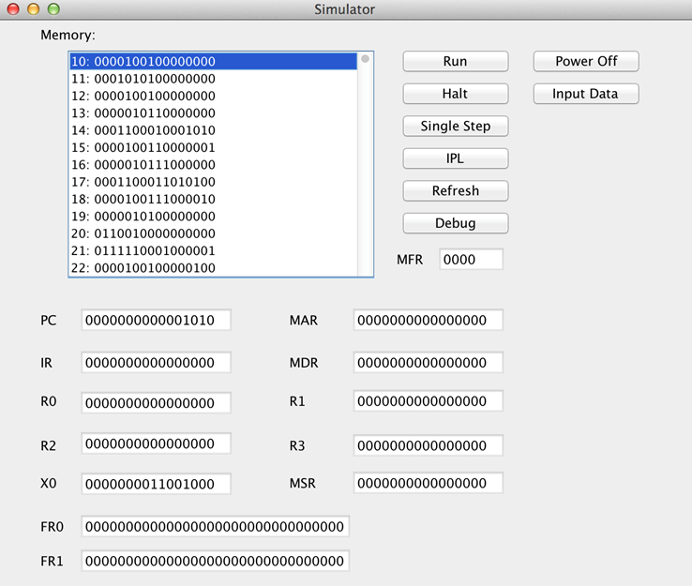

Then enter 21 integers into the Console Input. In this case, you may input 1~20, then input 4.

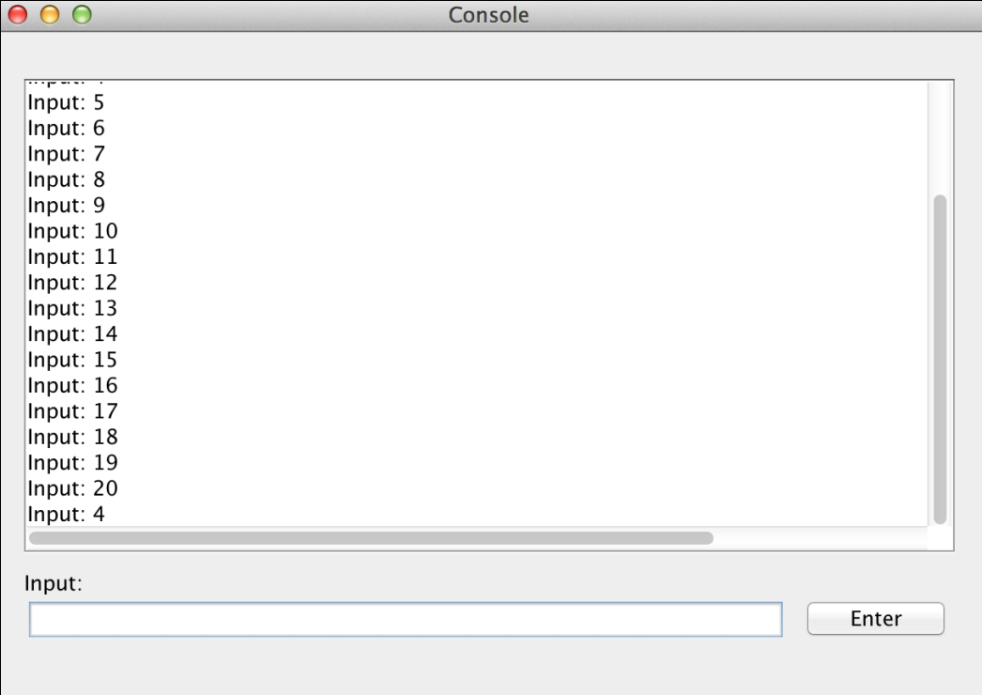

Input the number from you physical keyboard or virtual keyboard. When you finish one integer, just click Button “Enter” or push the key “Enter” on your keyboard.



Click Button “Run” to run this program1, and you will see the following.

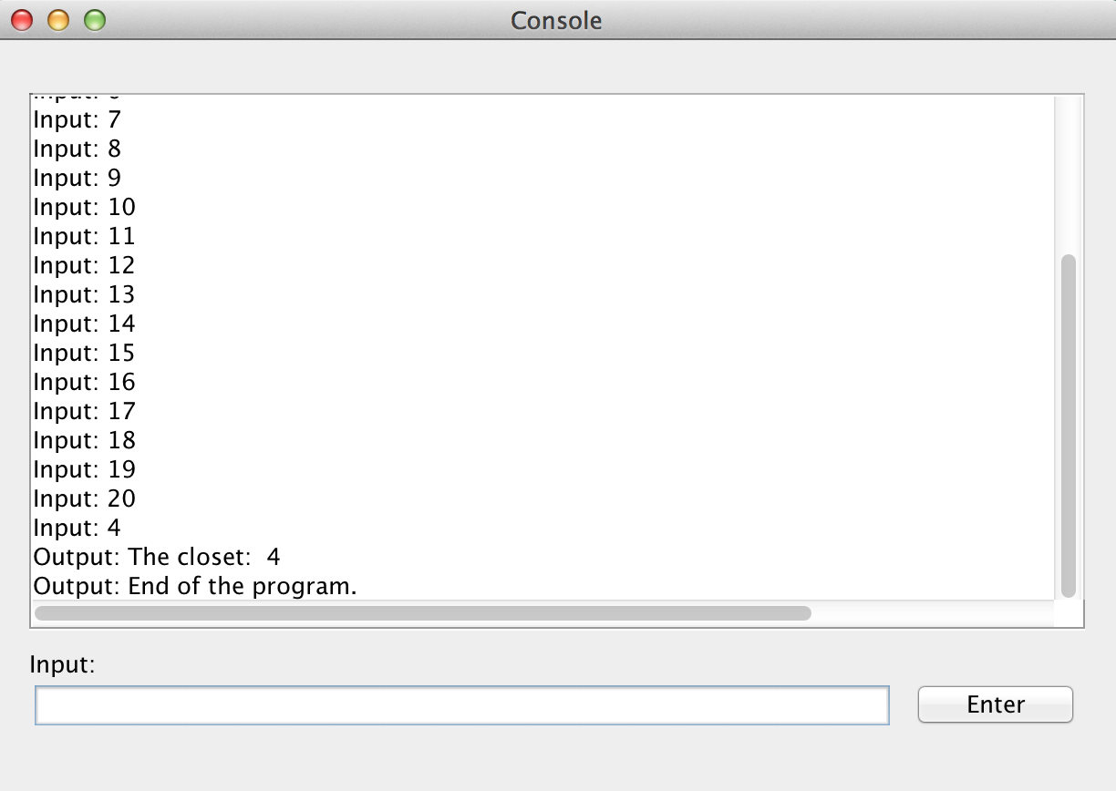

Congratulation! The Program 1 has been done successfully. The closet number is 4.

* 1. Test 2

When you finish the initialization and all data in this simulator are correct, you can see the window as following(Please use program1.txt when choosing a file to load memory.).



Then enter 21 integers into the Console Input. In this case, you may input 0,1,2,3,4,5,6,7,8,9,10,11,12,13,14,15,16,17,19,20, then input 18.

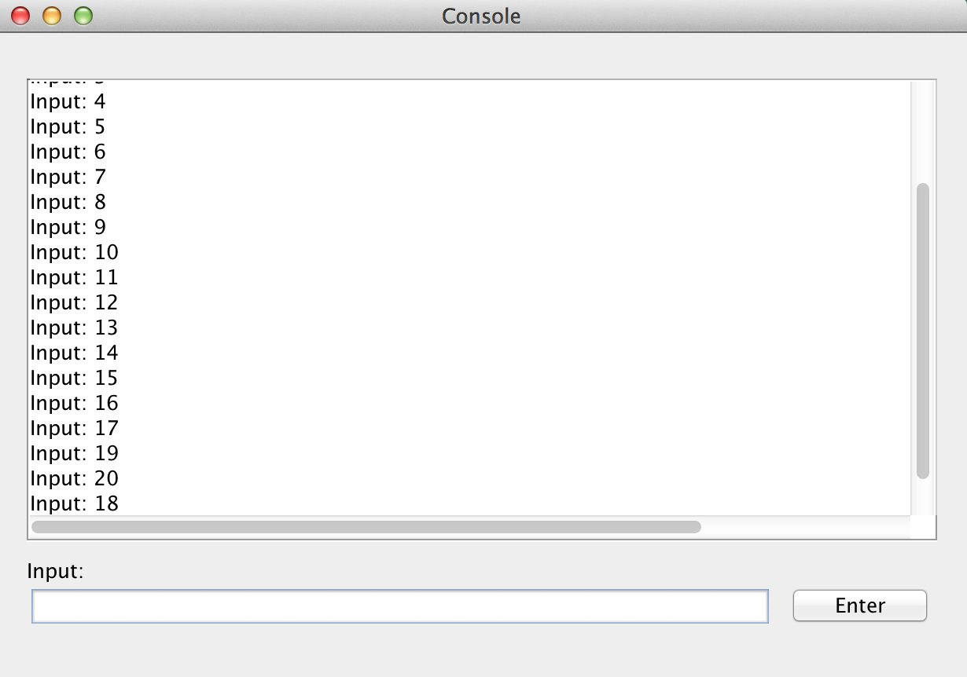

Input the number from you physical keyboard or virtual keyboard. When you finish one integer, just click Button “Enter” or push the key “Enter” on your keyboard.



Click Button “Run” to run this program1, and you will see the following.

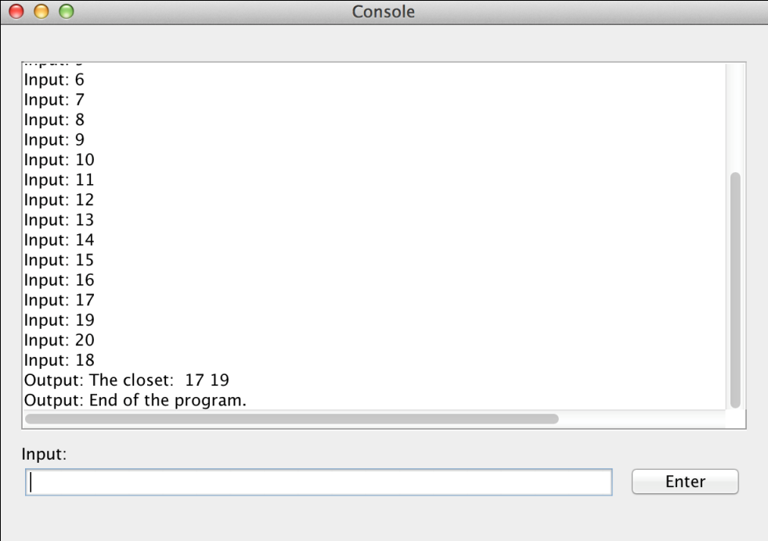

Congratulation! The Program 1 has been done successfully. The closet numbers are 17 and 19.

1. RunProgram2
   1. Test 1

When you finish the initialization and all data in this simulator are correct, you can see the window as following(Please use program2.txt when choosing a file to load memory.).



Then enter 21 integers into the Console Input. In this case, you may input 1~20, then input 4.



Input the number from you physical keyboard or virtual keyboard. When you finish one integer, just click Button “Enter” or push the key “Enter” on your keyboard.



Click Button “Run” to run this program1, and you will see the following.



Congratulation! The Program 1 has been done successfully. The closet number is 4.

* 1. Test 2

When you finish the initialization and all data in this simulator are correct, you can see the window as following(Please use program1.txt when choosing a file to load memory.).



Then enter 21 integers into the Console Input. In this case, you may input 0,1,2,3,4,5,6,7,8,9,10,11,12,13,14,15,16,17,19,20, then input 18.



Input the number from you physical keyboard or virtual keyboard. When you finish one integer, just click Button “Enter” or push the key “Enter” on your keyboard.



Click Button “Run” to run this program1, and you will see the following.



Congratulation! The Program 1 has been done successfully. The closet numbers are 17 and 19.

1. RunFloat&Vector Test
   1. Explanation of Float&Vector Test Codes

PC starts at 10!!

0000000000000000

0000000000000000

0000000000000000

0000000000000000

0000000000000000

0000000000000000

0000000000000000

0000000000000000

1010110000010110 LDFR

1011000000100000 STFR

1000010000011010 FADD

1000100000011110 FSUB

0001100000010100 R0 + 20: the length of each vector is 20;

1000110000100010 VADD

1001000000100010 VSUB

1001010000100001 CNVRT to fixed point

1001010001100001 CNVRT to float point

0000000000000000

0000000000000000

0000000000000000

1001100110011010 data for LDFR

0011111110011001

0000000000000000

0000000000000000

0110011001100110 data for FADD

0011111111100110

0000000000000000

0000000000000000

0011110101110001 data for FSUB

0011111100001010

0000000000000000

0100100110011011 data for CNVRT

0000000000100110 address of Vector 1

0000000001010000 address of Vector 2

0000000000000000

0000000000000000

1011100001010010 data of Vector 1

0011111110011110

1100001010001111

0100000001110101

0110011001100110

0100000010000110

0011001100110011

0100000011110011

0110011001100110

0100000100000110

1101011100001010

0100000100100011

1110000101001000

0100000100010010

0101000111101100

0100000111000000

1000111101011100

0100001000101000

0011001100110011

0011111110110011

0100011110101110

0011111100100001

0111000010100100

0100000101001101

0011001100110011

0100000100010011

1100110011001101

0100000010001100

0101000111101100

0100000011000000

1110101110000101

0100000100000001

0111000010100100

0100000101111101

0001111010111000

0100000110001101

1001100110011010

0100000111101001

0110011001100110

0100000111110110 End of Vector 1

0000000000000000

0000000000000000

0110011001100110 data of Vector 2

0100000000000110

0011110101110001

0100000010011010

0010100011110110

0100000100010100

1100001010001111

0100000100100001

1010111000010100

0100000010110111

0000000000000000

0100000011011000

0011001100110011

0100000011100011

0101000111101100

0100000100000000

1100110011001101

0100000110010100

1001100110011010

0100000111001101

0111000010100100

0011111101111101

0001111010111000

0100000011101101

0000101000111101

0100000010100111

0001010001111011

0100000011000110

0111101011100001

0100000000000100

0011001100110011

0100000111111011

1010111000010100

0100000110011001

1100110011001101

0100000111001000

0011001100110011

0100000100011011

1010001111010111

0100000100101000 End of Vector 2

* 1. Start

When you finish the initialization and all data in this simulator are correct, you can see the window as following(Please use Float&Vector Test.txt when choosing a file to load memory.).

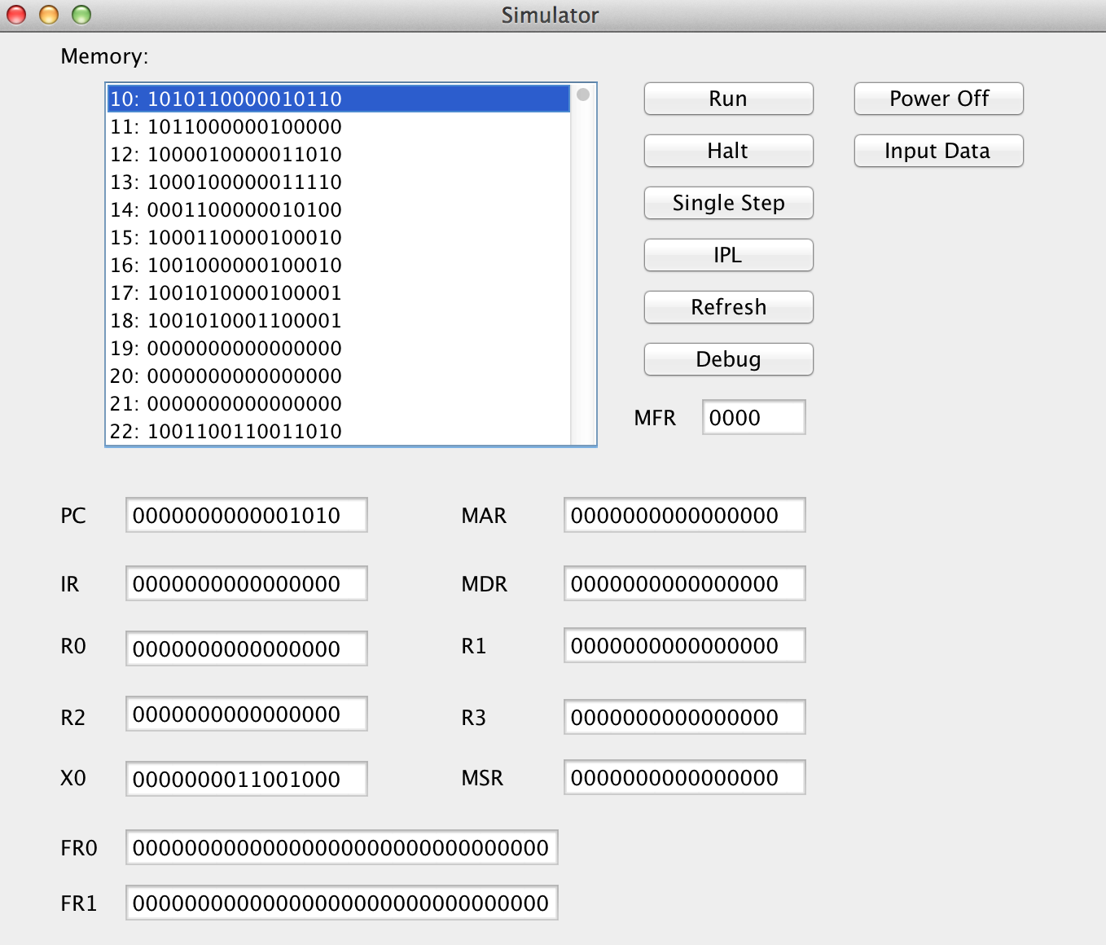

Then, click “Single Step” to test this file step by step. You can click “Run” to see the result, as well.

* 1. LDFR

Click “Single Step” and you will see the simulator like following.

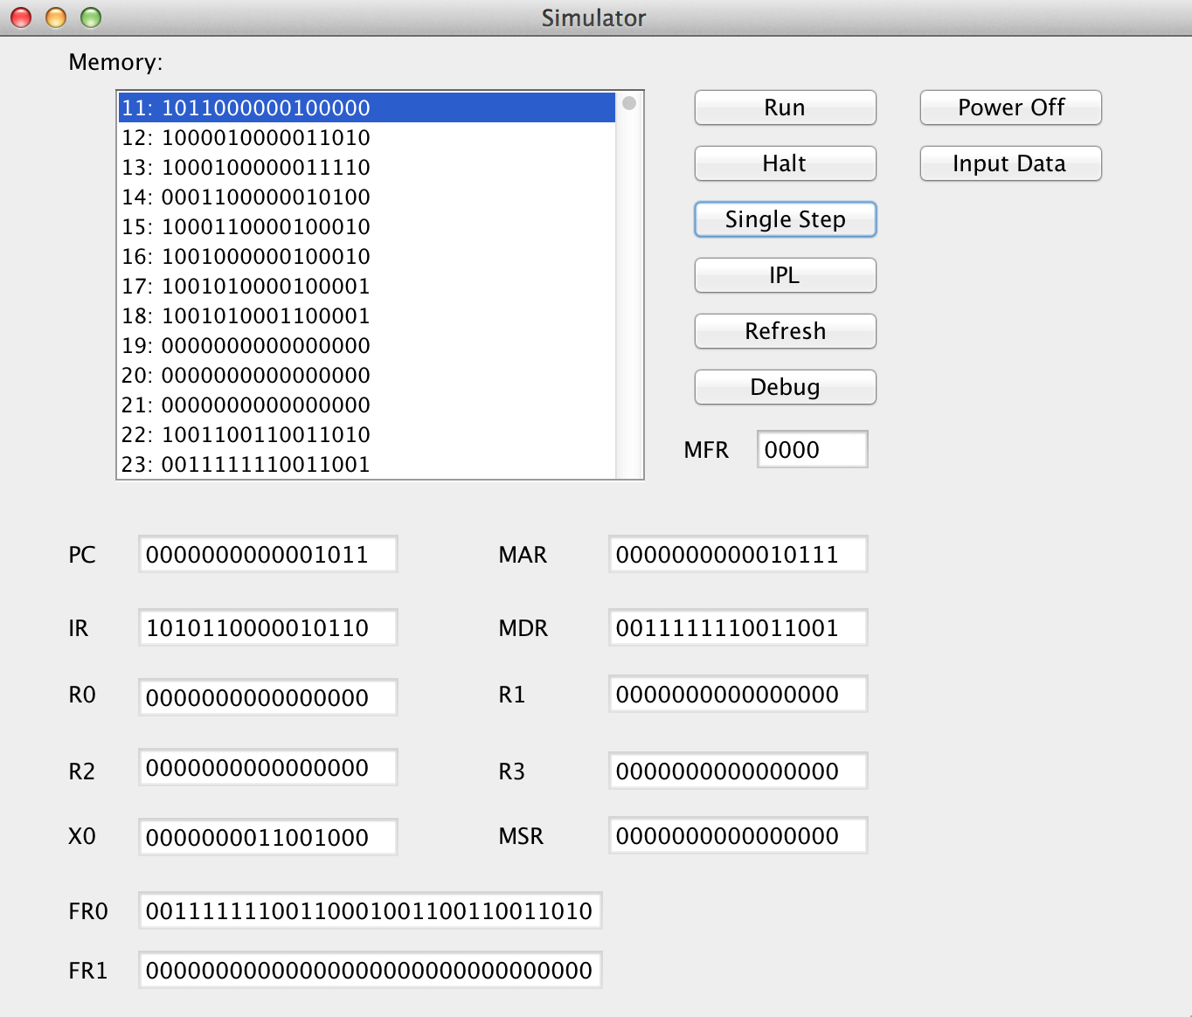

Congratulation! The value of FR0 is correct.

* 1. STFR

Click “Single Step” and you will see the simulator like following.

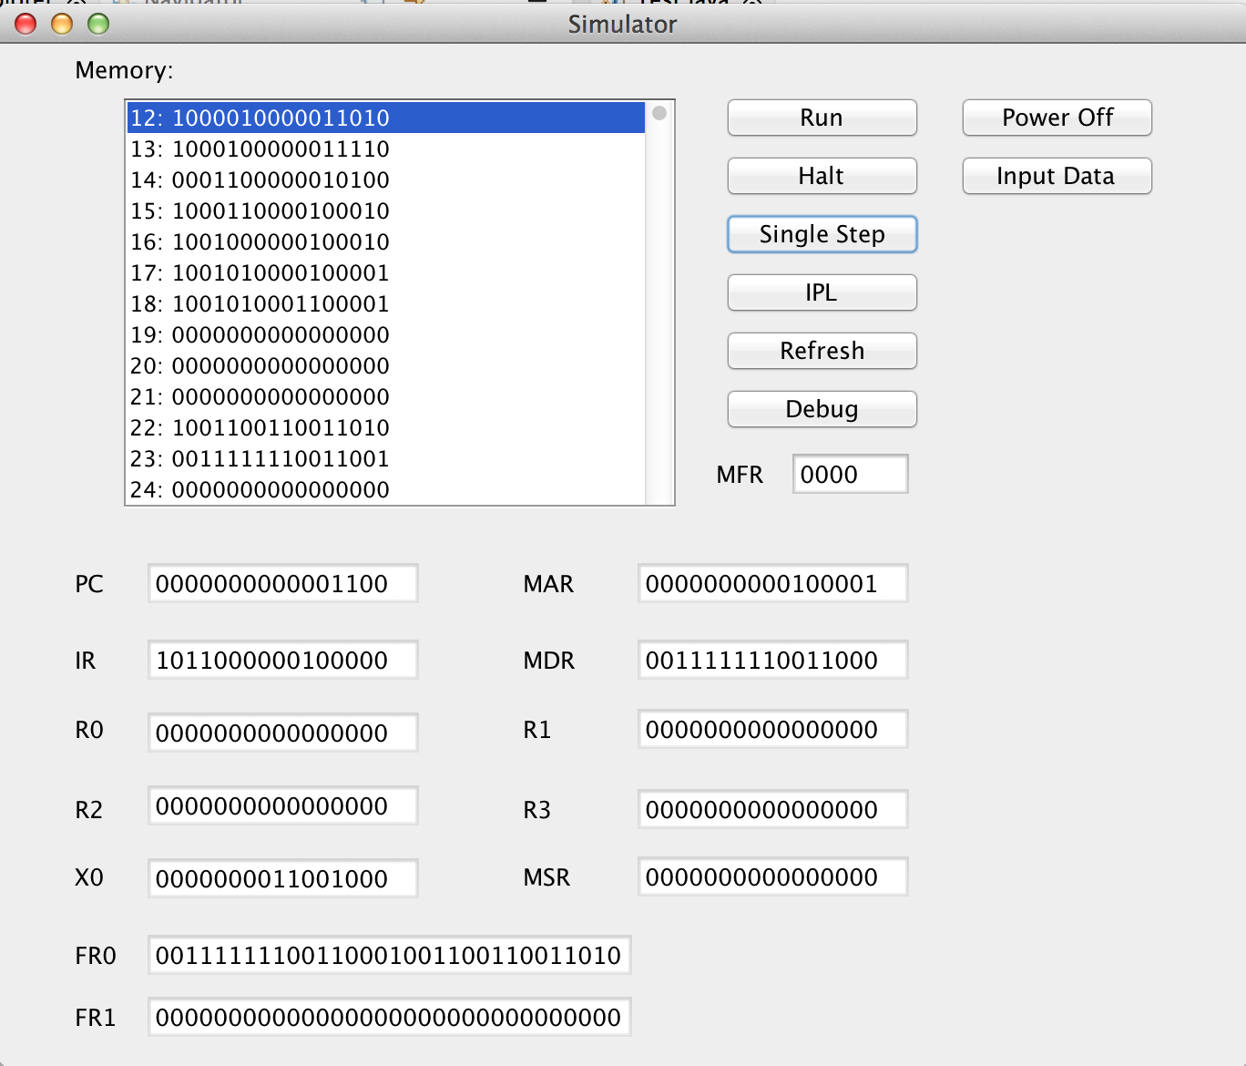

Congratulation! The action of STFR is correct.

* 1. FADD

Click “Single Step” and you will see the simulator like following.

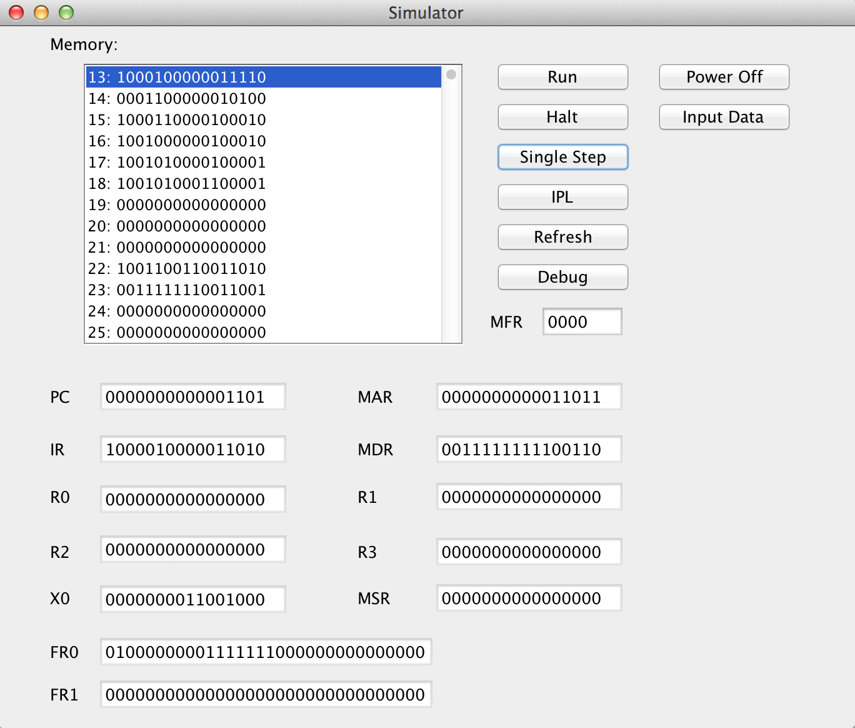

Congratulation! The action of FADD is correct.

* 1. FSUB

Click “Single Step” and you will see the simulator like following.

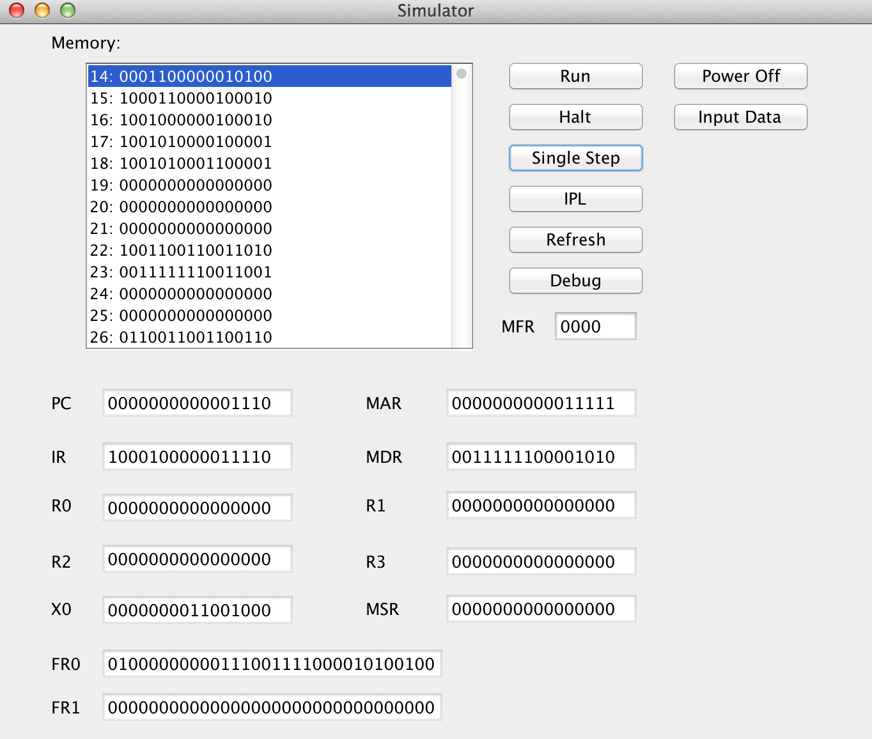

Congratulation! The action of FSUB is correct.

* 1. VADD

Click “Single Step”once to put the length of vector into R0, and click “Single Step” again, you will see the simulator like following.

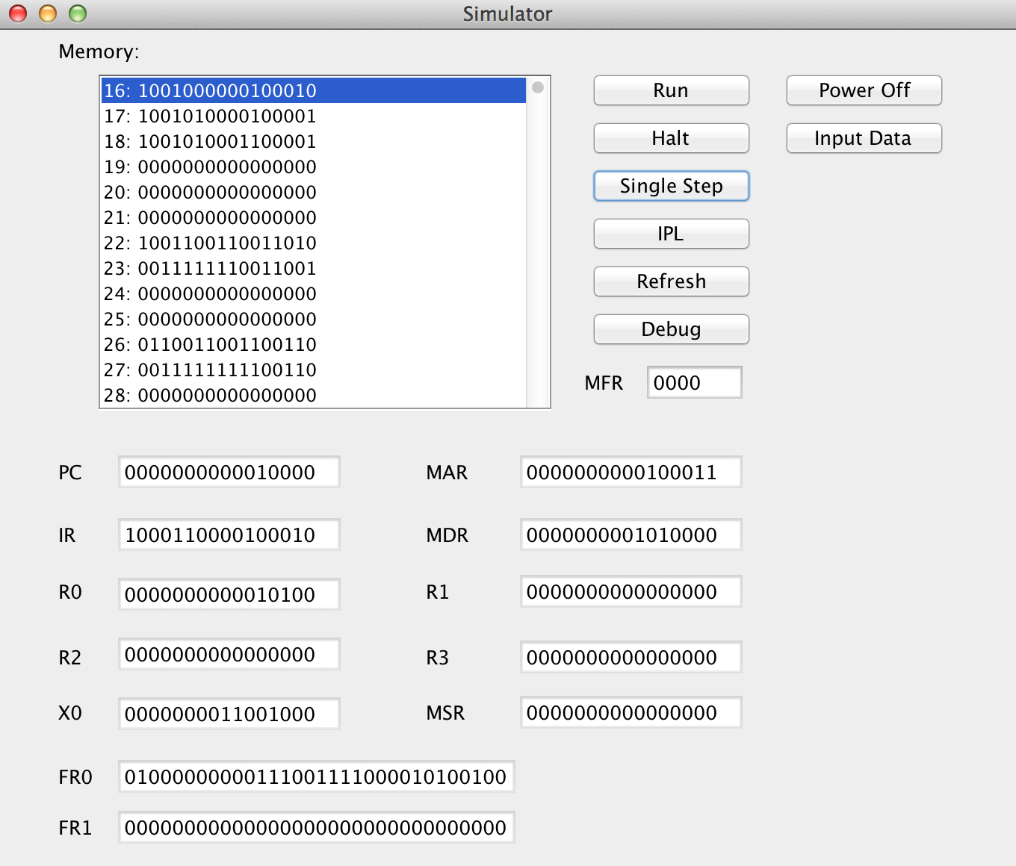

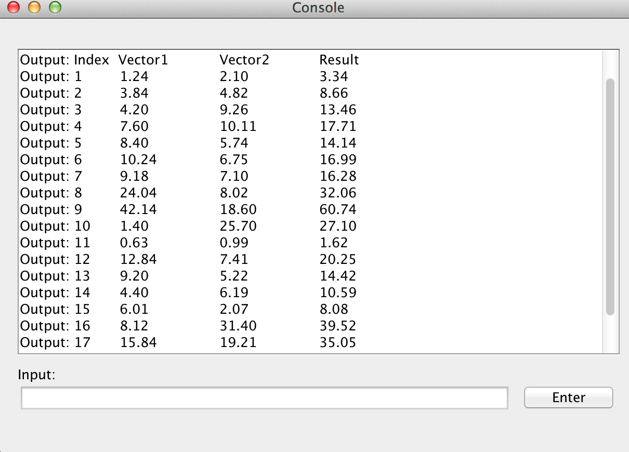

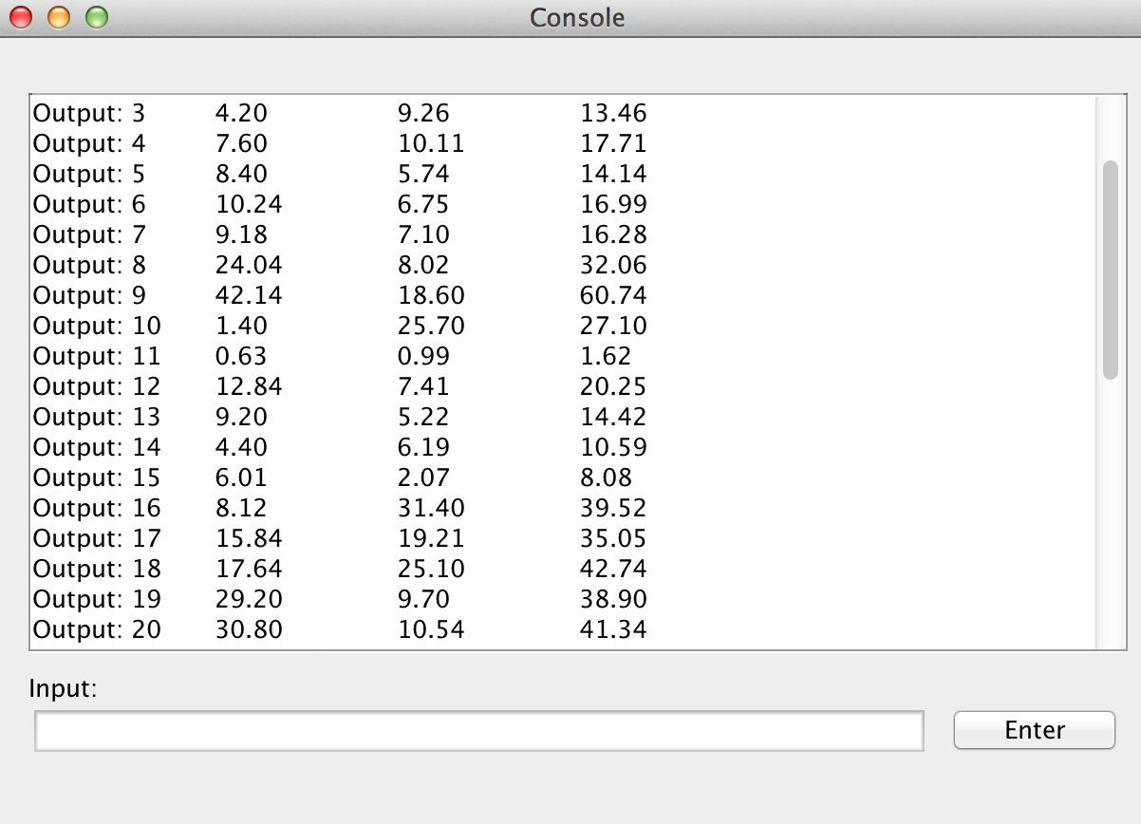

Congratulation! The action of VADD is correct. You can see the result list on the console. There is a list of 20 results in the vector.

* 1. VSUB

Click “Single Step”, and you will see the simulator like following.

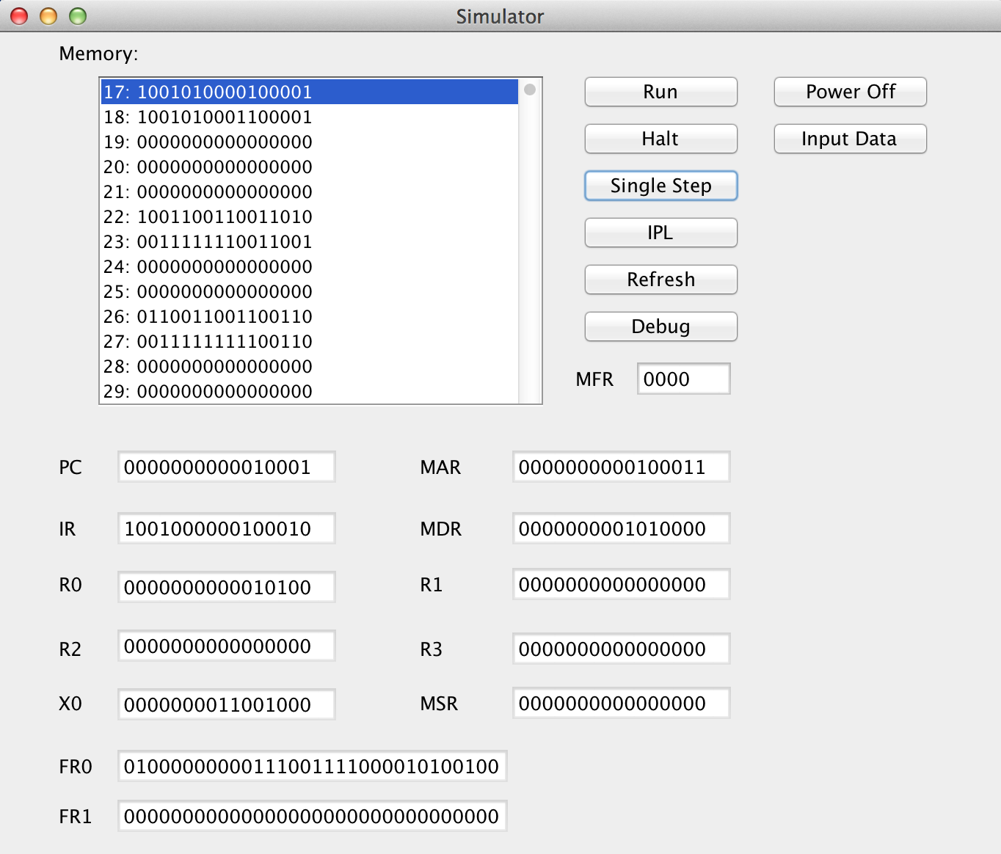

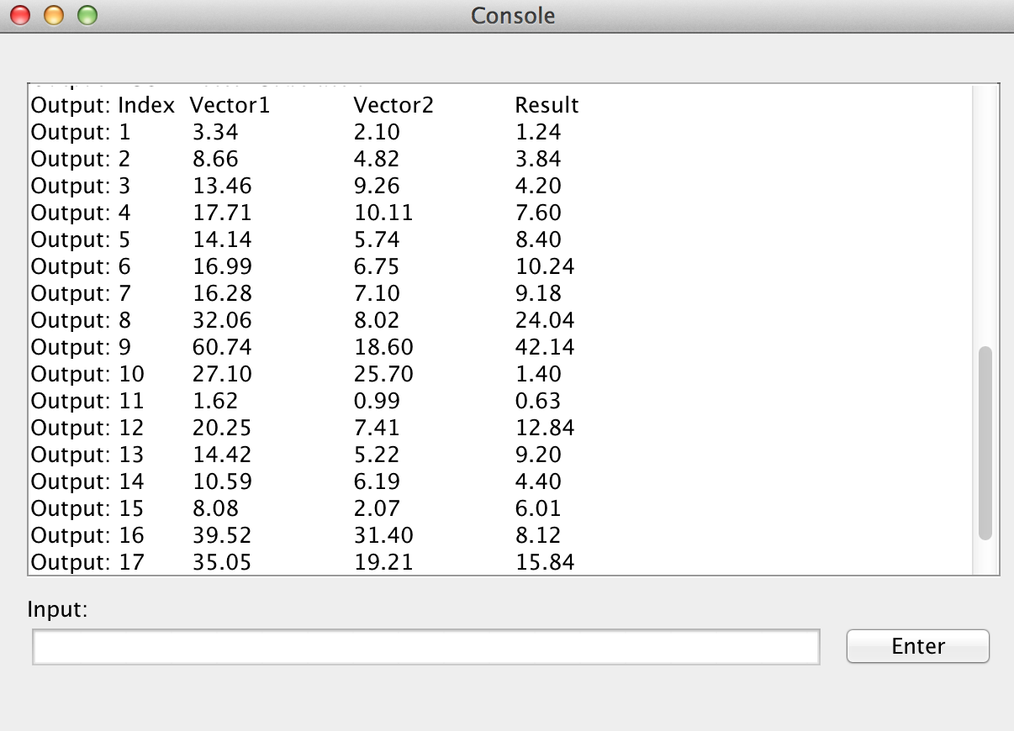

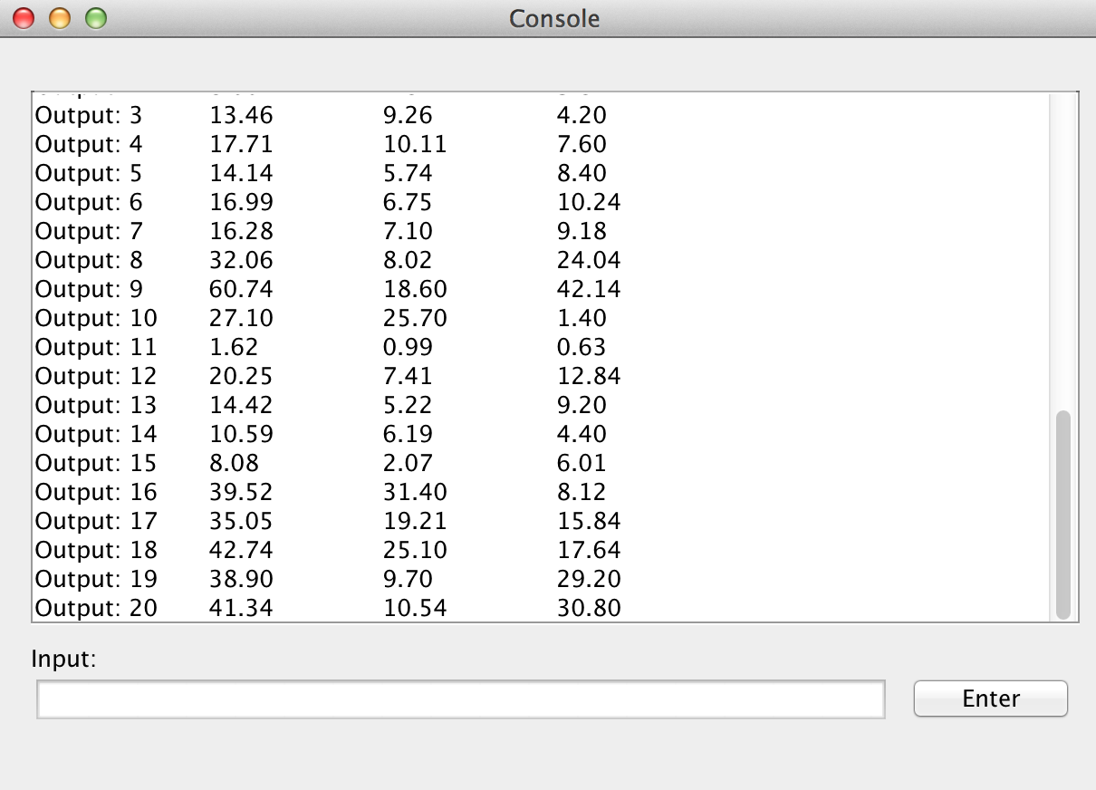

Congratulation! The action of VSUB is correct. You can see the result list on the console. There is a list of 20 results in the vector.

* 1. CNVRT to fixed point

Click “Single Step” and you will see the simulator like following.

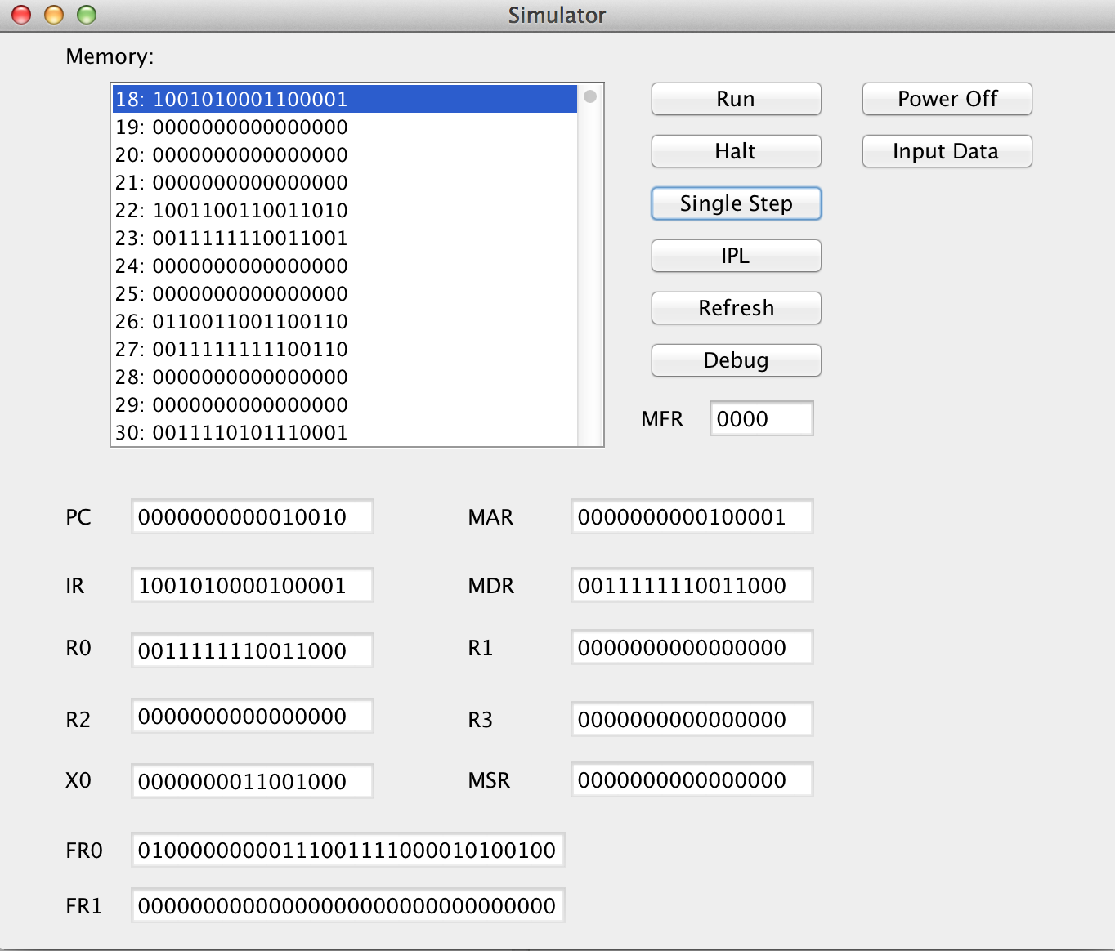

Congratulation! The action is correct.

* 1. CNVRT to float point

Click “Single Step” and you will see the simulator like following.

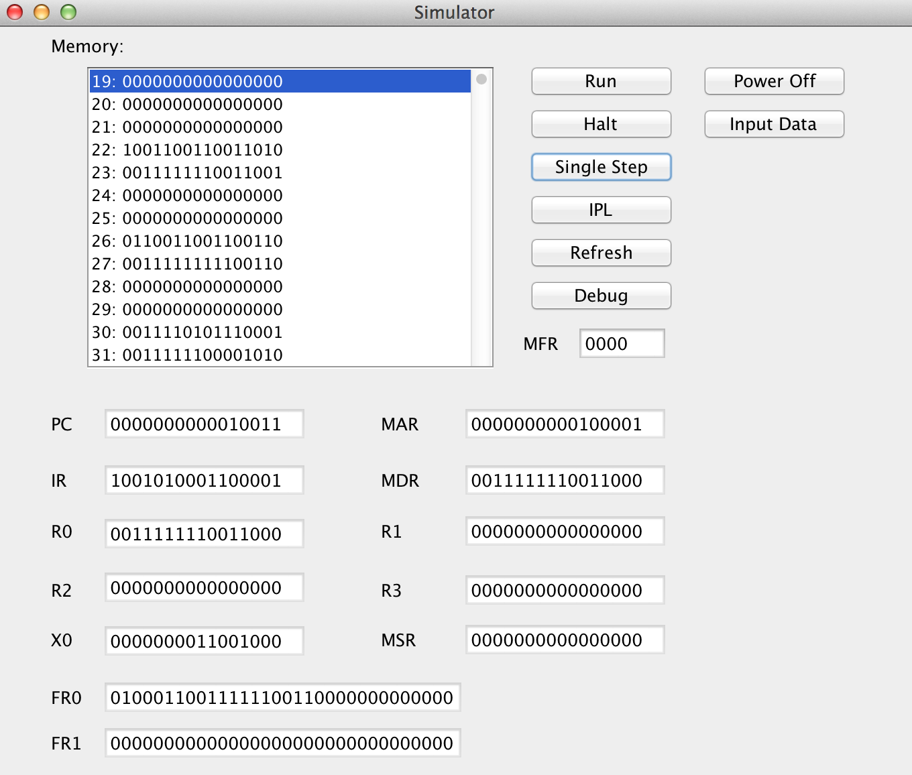

Congratulation! The action is correct.